Task-1:
import java.util.*;
import java.util.stream.*;
public class SecondHighestUsingStream
{
public static void main(String[] args)
{
Scanner sc = new Scanner(System.in);
int n = sc.nextInt(); List list = new ArrayList<>();
for (int i = 0; i < n; i++) {
list.add(sc.nextInt());
}
int result = list.stream() .distinct() .sorted(Comparator.reverseOrder()) .skip(1) .findFirst() .orElse(-1);
System.out.println(result);
}
}
Output:
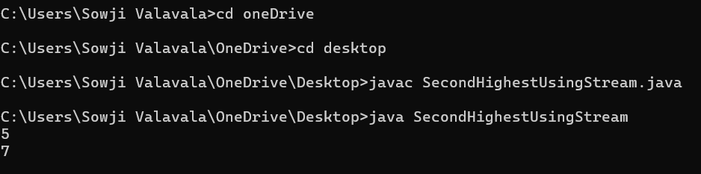

Task-2:
public static PerformOperation isOdd() {
return i -> { return i % 2 != 0 ? true : false;
};
}
public PerformOperation isPrime() {
return i -> { if (i == 2) return true; if (i <= 1 || i % 2 == 0) return false;
int numberSqrt = (int)Math.sqrt(i); for (int j=3; j<=numberSqrt; j+=2) {
if (i % j == 0) return false;
}
return true; }; }
public static PerformOperation isPalindrome()
{ return i -> {
String numberStr = String.valueOf(i);
String reversedStr = "";
for (int j=numberStr.length()-1; j>=0; j--)
{
reversedStr += numberStr.charAt(j); } return numberStr.equals(reversedStr); }; } }
output:
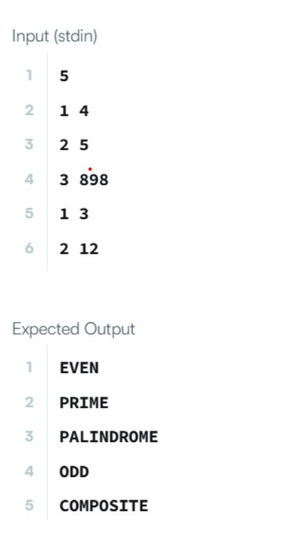

task-3:
public static void miniMaxSum(List arr)
{
long sum = arr.stream().mapToLong(Integer::longValue).sum();
int min = Collections.min(arr); int max = Collections.max(arr); System.out.println((sum - max) + " " + (sum - min));
}
}
Output:
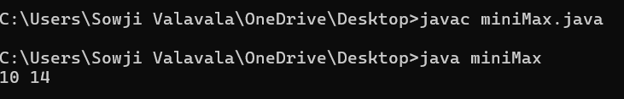

Task-4:
import java.util.*;
import java.util.stream.*;
class Person { String name; int age; Person(String name, int age) {
this.name = name; this.age = age;
}
public String getName() { return name;
}
public int getAge() { return age;
}
// Static method for filtering public static boolean isOlderThanLimit(Person p, int ageLimit) { return p.age > ageLimit;
}
}
public class MethodReferenceExample { public static void main(String[] args) {
Scanner sc = new Scanner(System.in); int n = sc.nextInt(); List persons = new ArrayList<>(); for (int i = 0; i < n; i++) {
String name = sc.next();
int age = sc.nextInt();
persons.add(new Person(name, age));
}
int ageLimit = sc.nextInt();
// Sort names alphabetically using method reference persons.stream() .map(Person::getName) .sorted(String::compareTo) .forEach(name -> System.out.print(name + " "));
System.out.println();
// Filter persons older than ageLimit using static method reference persons.stream() .filter(p -> Person.isOlderThanLimit(p, ageLimit)) .map(Person::getName) .forEach(name -> System.out.print(name + " "));
System.out.println();
// Convert all names to uppercase using instance method reference persons.stream() .map(Person::getName) .map(String::toUpperCase) .forEach(name -> System.out.print(name + " "));
}
}

Output:
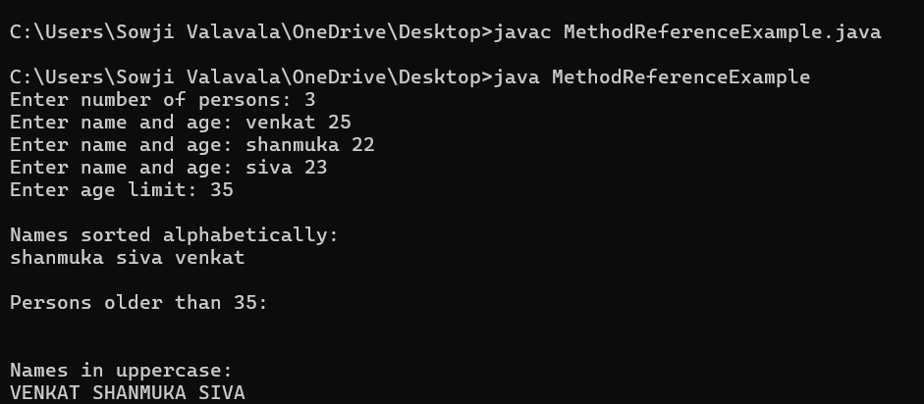

Task-5:
public int isPalindrome(String input1)
{
int left=0;
int right=input1.length()-1;
input1=input1.toLowerCase();
while(left+right);
{
if(input1.charAt(left)!=input1.charAt(right))
{
return 1;
}
left++; right--;
}
return 2;
}
}

Task:6
public int allDigitsCount(int input1)
{
int count=0; while(input1>0)
{
count++; input1/=10;
}
return count; /* ---------------ONE LINER---------------------- return String.valueOf(input1).length(); */ */
}
}

Output:
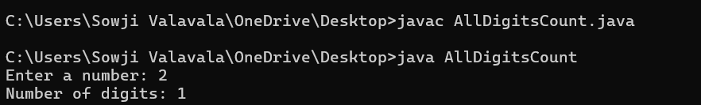

Task-7:
import java.time.LocalDate;
public static String findDay(int month, int day, int year)
{
return LocalDate.of(year, month, day) .getDayOfWeek() .toString();
}

Output:
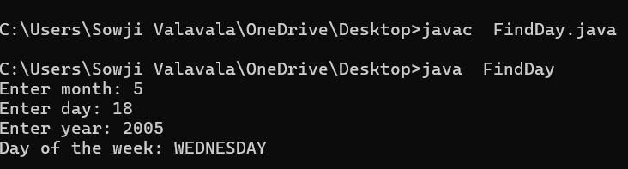

Task-8:
public class WeightHillPattern
{
public int totalHillWeight(int input1,int input2,int input3)
{
int sum=0; for(int i=0;i<=i;j++){ sum+=input2;
}
input2=input2+input3;
}
return sum;
}
}
Output:
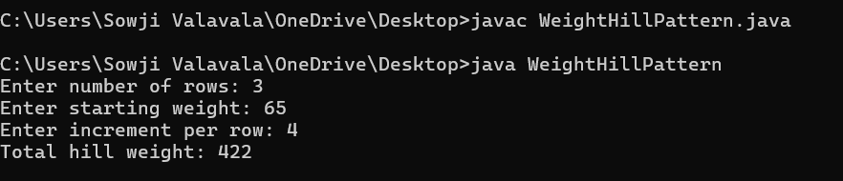

Task-9:
import java.time.LocalDate;
import java.util.*;
import java.util.stream.*;
class Event { String name; LocalDate date;
Event(String name, String date)
{
this.name = name; this.date = LocalDate.parse(date);
// yyyy-MM-dd
}
public String getName() {
return name;
}
public LocalDate getDate()
{
return date;
}
}
public class EventProcessor
{
public static void main(String[] args)
{
Scanner sc = new Scanner(System.in);
int n = sc.nextInt(); List events = new ArrayList<>();
for (int i = 0; i < n; i++)
{
String name = sc.next();
String date = sc.next(); events.add(new Event(name, date));
}
int month = sc.nextInt();
// Sort events chronologically List sortedEvents = events.stream() .sorted(Comparator.comparing(Event::getDate)) .collect(Collectors.toList()); sortedEvents.forEach(e -> System.out.print(e.getName() + " ")); System.out.println();
// Earliest event Event earliest = sortedEvents.get(0); System.out.println(earliest.getName());
// Latest event Event latest = sortedEvents.get(sortedEvents.size() - 1); System.out.println(latest.getName());
// Events occurring in the given month sortedEvents.stream() .filter(e -> e.getDate().getMonthValue() == month) .forEach(e -> System.out.print(e.getName() + " "));
}
}

Output:
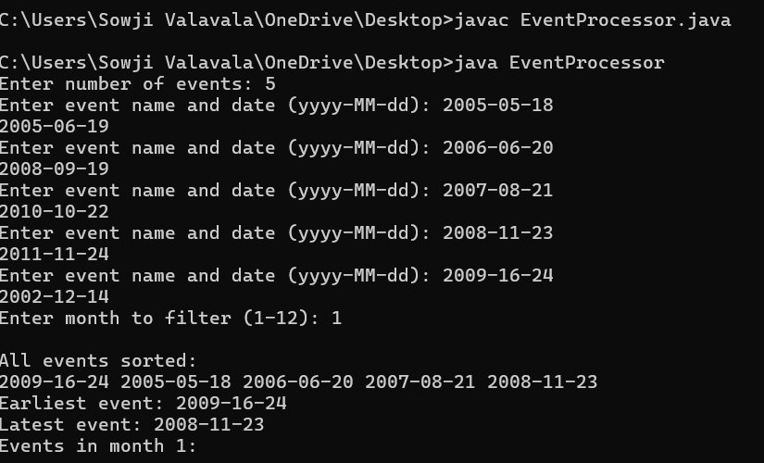

Task-10:
public int sumOfsumOfDigits(int input1)
{
String num = String.valueOf(input1);
int totalSum = 0; for (int i = 0; i < num.length(); i++)
{
int currentSum = 0;
for (int j = i; j < num.length(); j++)
{
currentSum += num.charAt(j) - '0';
}
totalSum += currentSum;
}
return totalSum;
}
Output:

